THE TRAGEDY OF FLIGHT: A COMPREHENSIVE CRASH ANALYSIS

**INTRODUCTION**

* 1. **OVERVIEW**

Aviation accident analysis is performed to determine the cause of errors once an accident has happened. In the modern aviation industry, it is also used to analyze a database of past accidents in order to prevent an accident from happening. Many models have been used not only for the accident investigation but also for educational purpose.

Per the Convention on International Civil Aviation, if an aircraft of a Contracting State has an accident or incident in another contracting State, the State where the Accident occurs will institute an inquiry. The Convention defines the rights and responsibilities.

**1.2 PURPOSE**

Although fight price come down over the years, things we took for granted now at an additional fee. While airlines and passengers battle over revenue extras versus bargains, the real opportunity is in creating now sources of revenue that leave customers feeling delighted, not taken behavioural economies can guide us. Searching for and purchasing tickets, checking in and even tagging luggage are now all digital experiencesconvenient,accessible, and speedy for the passenger and cost effective for the airline. As importantly, there are many ways that consumers can from their flight experiences feeling travel savvy and gratified.

Problem Definition & Design Thinking

**Empathy map**

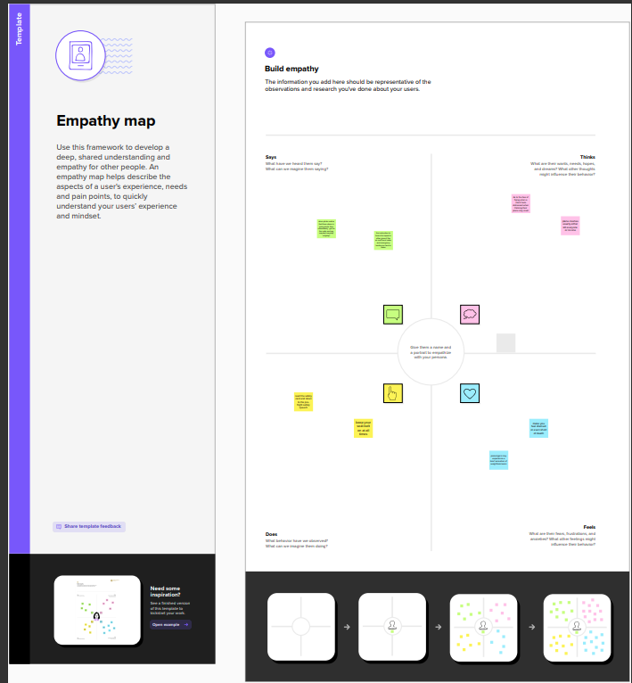

**Brain storming**

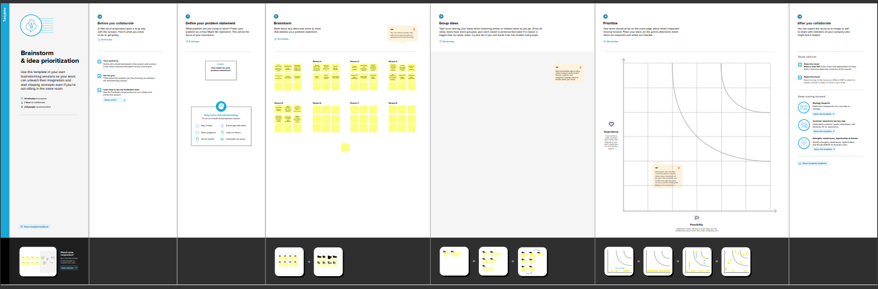

Result

**Dashboard**

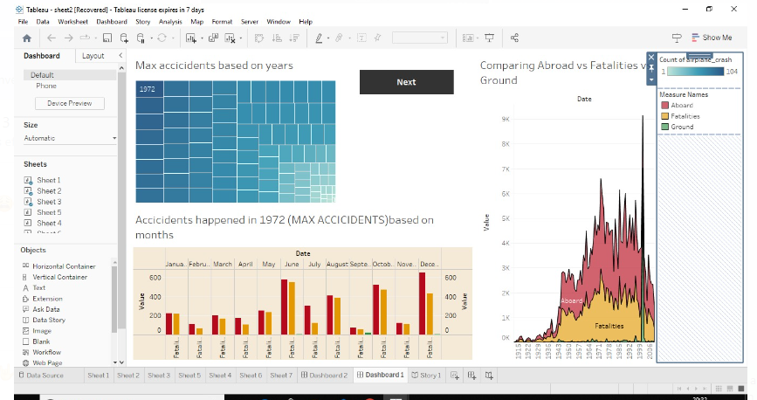

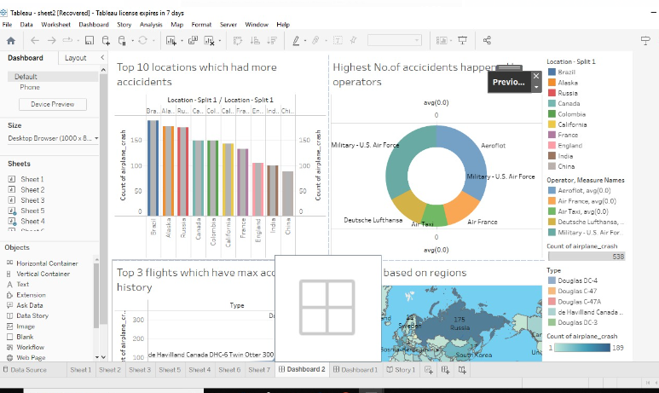

**Story**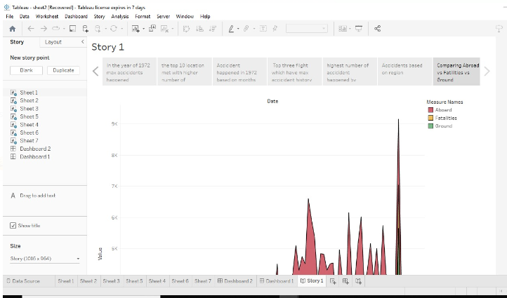

**Advantages**

The key to accident investigation, then, is to determine the error chain leading up to the event. Rectifying the situation regarding an accident under investigation is impossible, because the accident has already happened.

**Disadvantage**

* The odds of dying in a plane crash are about one in 11 million, but the chances of surviving depend on your seating choice.
* As with our previous efforts involving civil and military aviation (Wiegmann & Shappell, 1997, 1999, 2001a, 2001b), skill-based errors were the most prevalent form of aircrew error among the commercial aviation accidents examined. Particularly widespread were technique errors associated with handling or controlling the aircraft. More important, when the commercial data reported here were combined with our previous investigations of GA accidents (Wiegmann et al., 2005; Detwiler et. al., 2006) an interesting finding emerged.

**Application**

According to the NTSB investigations performed into air accidents, over 88 percent of all chartered plane crashes are attributed, at least in part, to pilot error. In private or general aviation, loss of aircraft control by the pilot is the number one cause of plane and airplane crashes.

**Conclusion**

* Be aware that you may do something careless or make errors at any moment, be sure to conduct periodic checks and prior confirmation, and try to take action as soon as possible instead of ignoring any abnormalities or anxiety you may notice during the flight. Such attitude of each pilot will lead to preventing aircraft accidents.
* Lastly, we extend our appreciation to the people from the Japan Flying Association and the AOPA-JAPAN.
* Who kindly responded to our interviews and offer our best wishes for their further success.

**Reference**

**Dashboard**

[**https://public.tableau.com/views/sheet2_16817381244940/Dashboard1?:language=en-US&publish=yes&:display_count=n&:origin=viz_share_link**](https://public.tableau.com/views/sheet2_16817381244940/Dashboard1?:language=en-US&publish=yes&:display_count=n&:origin=viz_share_link)

**Story**

[**https://public.tableau.com/views/sheet2_16817381244940/Story1?:language=en-US&publish=yes&:display_count=n&:origin=viz_share_link**](https://public.tableau.com/views/sheet2_16817381244940/Story1?:language=en-US&publish=yes&:display_count=n&:origin=viz_share_link)

**Appendix**

<file:///C:/Users/ELCOT/Downloads/index.html>